INMED Annual Report
July 2016

- ASM 2015 @ UL:
The eighth annual meeting of INMED was held at the graduate entry medical school, the University of Limerick. The conference theme was “New horizons and health professional education: Complexity, Culture and Communication. The conference was organised over 2 1/2 days including a full preconference workshop day and one half days of research and educational development presentations. The preconference day included the launch of itEACH as an affiliated group with INMED. itEACH is the Irish branch of the European Association for Communication in Healthcare, (EACH). Following its successful launch, itEACH has since held a follow up two-day symposium in March/April 2016 with the support of INMED. The preconference day also included a day-long workshop in which the accepted model of the OSCE was challenged and revisited using a “change laboratory” approach created by Yrjö Engeström. During the main conference keynote presentations by Tara Fenwick, (University of Stirling), Jonathan Silverman, (Cambridge University) and Anne Marie Cunningham, (NHS, Wales) covered a range of topics related to the theme including workplace learning, professional culture and interprofessional communication. The conference was a great success attracting over 200 delegates and many sponsors. INMED would like to sincerely thank the University of Limerick and the graduate entry medical school for their superb organisation and support throughout the conference.

- INMED faculty development symposium: Evidence Synthesis Venue UCC
INMED and the Medical Education Unit at UCC jointly facilitated a symposium on Evidence Synthesis in Health Professions Education at Brookfield Health Sciences Complex, UCC on February 19th 2016. The symposium was attended by more than 40 delegates from around Ireland, representing a diverse range of disciplines including Medical Education, Epidemiology and Public Health, Psychiatry, Dentistry, Nursing, Occupational Therapy, Audiology, Psychology and Marketing & Management. Dr. Andrew Booth, Reader in Health Evidence Based Information Practice at ScHARR, University of Sheffield, gave an excellent plenary in which he presented a toolkit of approaches which can be matched to research question, theoretical orientation, available resources and purpose of the review. He described how the field has moved on from a single conventional approach, the systematic review as defined by the Cochrane Collaboration, to a multitude of options. He went on to explore these newer approaches and what they can offer health professions education. There followed workshops which provided tasters of methodologies of evidence synthesis; Introduction to Systematic Reviews (Dr. Andrew Booth), Introduction to Qualitative Evidence Synthesis (Dr. Martina Kelly, University of Calgary, and Prof. Tim Dornan, QUB.) and Introduction to Realist Reviews (Dr. Geoff Wong, University of Oxford). These were very well received and delegates evaluated the symposium as a whole as a valuable learning experience.

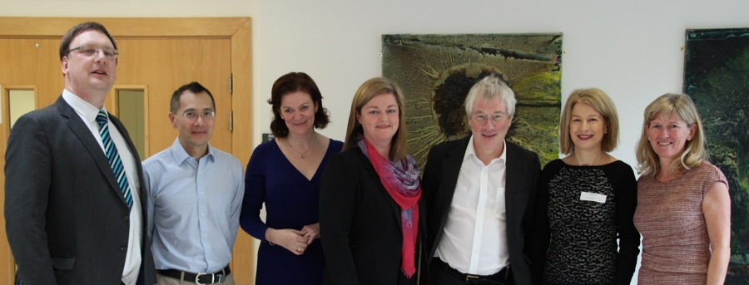
(left to right: Andrew Booth; Geoff Wong; Martina Kelly; Deirdre Bennett; Tim Dornan; Deirdre McGrath)
- itEACH
In February 2015, the Irish branch of the European Association for Communication in Healthcare (EACH) organisation was launched at the 8th INMED Annual Scientific Meeting held at the University of Limerick. The launch was organised by Dr Veronica Lambert, Dublin City University and Dr Eva Doherty, Royal College of Surgeons in Ireland who are the EACH national representatives for Ireland. A workshop on teaching communication skills to health professionals was convened by Johnathan Silverman, President of EACH and co-author of the Calgary-Cambridge framework of communication skills in medicine. Jonathan also gave a Keynote address at the INMED meeting.

The new itEACH branch is a free standing organisation affiliated to INMED and has 70 individuals already registered in the network . itEACH held its first event in March 2016 in which Dr Paul Kinnersley, (University of Cardiff) led a two day workshop on ‘What to Teach’ in relation to communication in healthcare. RCSI were the hosts and 16 tutors attended from medicine, physiotherapy and nursing. Many parts of Ireland and colleges were represented from Galway to Dublin to Donegal.

A general meeting of itEACH will take place on September 15th 2016 in University College Dublin to plan for future events. Dr Eva Doherty will present a short talk on ‘The Assessment of Communication Skills: Evidence from the Literature re the Reliability and Validity of Scoring Methodologies’. If you are interested in attending and/or getting involved, please email Eva Doherty at edoherty@rcsi.ie.

- INMED Communicates: “Mailchimp”
INMED launched its new “mailchimp” news feed in 2015-16. The mailchimp messaging system replaces our quarterly ezine allowing us to send newsletter type messgaes, links and notifications via email to INMED members at short notice rather than scheduling our notifications to four times a year.

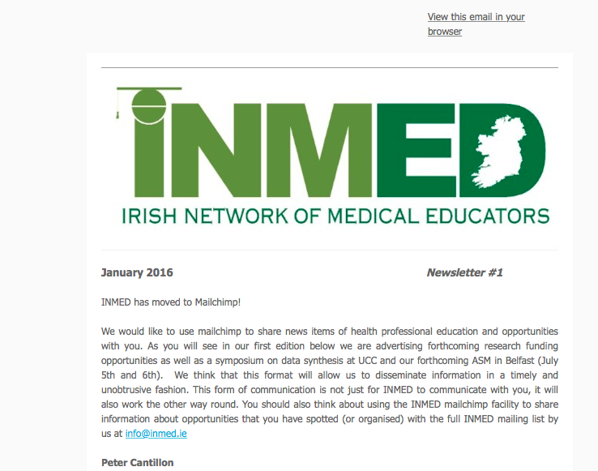

- INMED Communicates: Our new website
While INMED has managed with the existing website to date the website has not fully met the needs of the Network being cumbersome to navigate and update for both users and administrators as well as being restrictive in its ability to attract and communicate with its target audience. A new website has been developed with the web design company CopperReed in Limerick to overcome the difficulties of the original site and will promote the network’s online presence to all health care educators and students in Ireland and abroad. The website will support the running of conferences, symposia and grant applications, as well as providing resource areas for members. It is anticipated that the new website will increase the impact and influence of INMED, grow membership and collaborations and will increase income which in turn will enable the development of further member services. The website will be launched at the INMED Annual Scientific Meeting in Belfast on the July 6th 2016. Feedback will be invited on the new website to ensure that it meets the demands of its users.

- INMED Research and Travel Grants
INMED launched its first Research and Travel Bursaries in 2014. Since then 6 research awards and 4 travel bursaries have been granted. The successful applicants from 2015 will be presenting the outcomes of their research/travel at the ASM on Tuesday July 5th. The 2016 – 17 bursaries were awarded in May/June 2016 and the five successful applications will be announced at the Belfast ASM.

Three types of applications are possible under INMED Research and Travel bursaries:

- Educational Research Grant (ERG)
- Travel Bursary
- Research in Medical Education Grant (RiME)

The Educational Reearch Grant helps to support planned research and innovation in healthcare education, feasible within a 12 month period. This year there were 7 applicants under this scheme in 2016. Two assessors from the field of medical education research in Ireland adjudicated each application based on published criteria. The two recipients of this year’s Education Research Grants, worth up to €1,500 each, will be announced at the ASM in July.

The Travel Bursary helps to support traval and/or registration costs associated with healthcare education conferences, (excluding INMED events), healthcare education training /faculty development events or visits to host institutions for the purposes of furthering educational research collaboration. This year there were 5 applications submitted for up to 2 awards of up to €1000 each. The 2 successful applicants will be announced at the ASM in July.

The application and assessment process worked well this year. Next year for ERG and travel bursary adjudications, a numerical guide for marking each descriptor, rather than just an overall mark for a particular section in which there are several descriptors, may help align adjudicator marks for this award.

While Educational Research Grant and Travel Bursary have been open to applicants annually since 2014, a collaboration with the Irish Medical Council in 2015 saw the launch of Research in Medical Education (RiME) grants with application via INMED. These consist of jointly funded awards of up to €6000 each covering the continuum of medical education that seek to answer questions of national and international importance, while contributing to the knowledge-base for Irish medical education and training. The intended impact of such awards is that they will support research to ‘influence medical education and training policy at every level’, addressing ‘questions and topics that really matter’ (Freddie Wood, IMC 2015). To date, three RiME awards have been made. Two projects are currently underway and the third did not go ahead due to difficulties with ethical approval. There were significant delays in the case on of one project due to the fact that INMED is not a legal entity and the University in question requested a contract with the Medical Council, rather than INMED.

For the 2016-17 RiME call, there were 8 applications. Each was assessed by a single reviewer provided by the Scottish Medical Education Corsortium (SMERC), to meet the published strict criteria. In 2015-16 each application was reviewed by two reviewers. We will endeavour to work closely with SMERC into the future, and to ensure at least two assessors will be provided per application per year. This year’s successful awardees will be announced at the Belfast INMED ASM in July. Various initiatives to build the quality of the grant applications being received are under discussion by the Executive, including holding a research summit, running a pre-application phase with partnering with more experienced researchers and providing better guidance to applicants.

Finally, an issue that also requires consideration is the number of times that successful applicants can apply in the following years. For example a rule that exists for T&L grants at UCC is successful applicants must wait 5 years before re-applying. We may consider applying a 3 year rule to the INMED Research and Travel bursaries.

- INMED 2016 will be held on July 5th and 6th at the Hilton hotel in Belfast.

